**Global Video Game Trends**



By: Cameron Kilpatrick, Jacob Stegal, Yuli Likhonina, & Yash Patel

1. What are the leading regions across global video game sales?   
   1. Why does North America have the most sales in comparison to the rest of the world?

The leading region for global video game sales is North America followed by the European Union, Japan, and Other countries that include Africa, Asia (excluding Japan), Australia, and South America. The United States has one of the largest video game markets and is one of the leading countries for video game revenue. The top 3 global video game publishers are Nintendo, Activision, and Electronic Arts, with Activision and Electronic Arts being American based. Japanese electronic product brands are also very popular in the United States. These are leading factors that can contribute to North America’s dominance in global sales across the regions.

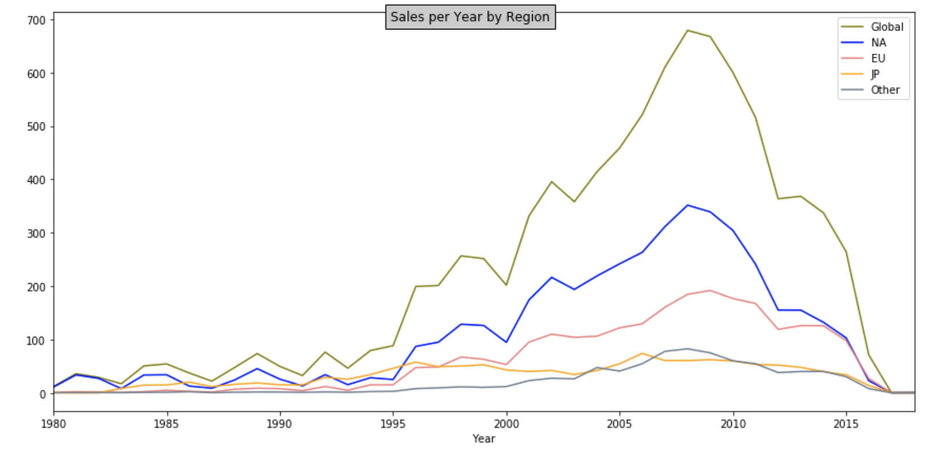

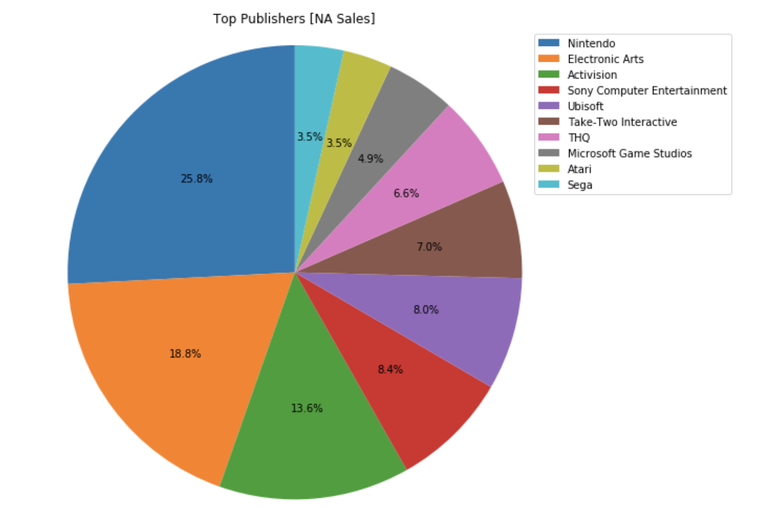

1. What are the drivers for the top video game release years?  
   1. Why did sales increase starting in the year 2000?
   2. How have the leading publishers influenced sales throughout the years?

Starting in the year 2000 more of the interactive games were released such as PS allowing users a new way of playing video games. Soon after the DS was released in 2004 closely following was the Xbox 360 in 2005. Leading up to the release of the PS3 and the Wii in 2006. With each progressing model there was an increase in the sales trend line.

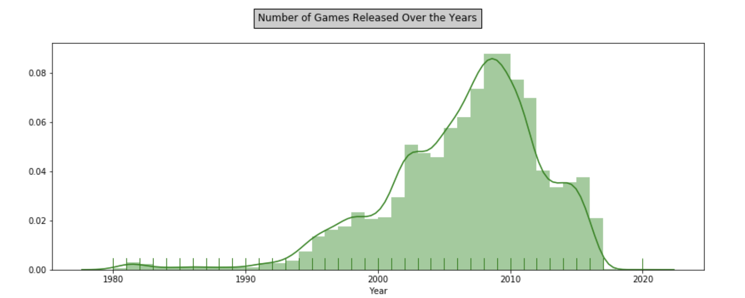

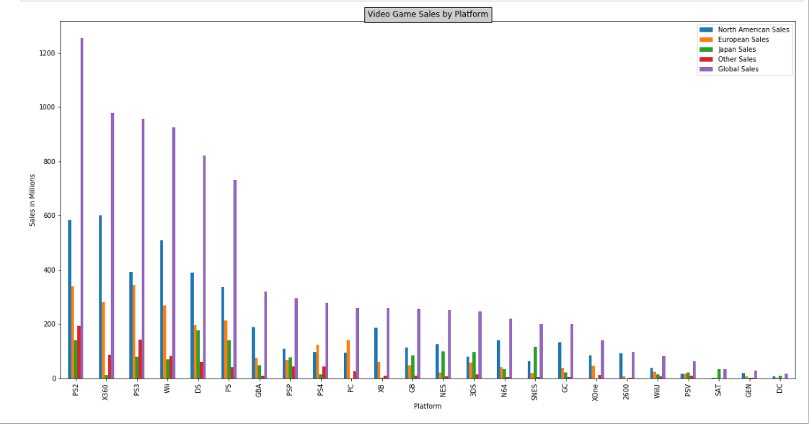

3. What are the top video game publishers over the regions?

1. Why does the Others region have the highest popularity in Electronic Arts while Nintendo leads globally?

The top video game publishers in global sales were Nintendo, Electronic Arts, and Activision. There were a couple of different correlations with the top video games and publishers being the first. The top video games were Wii Sports, Super Mario Bros, Mario Kart Wii, and Wii Sports Resort. These top four video games are published by Nintendo which explains why Nintendo is the top publisher. The second correlation we found was between sales by genre and other sales publishers. The top two genres in the other sales were sports and action. Electronic Arts publishes mainly sporting games and action games which explains why the other sales have Electronic Arts as the top publisher.

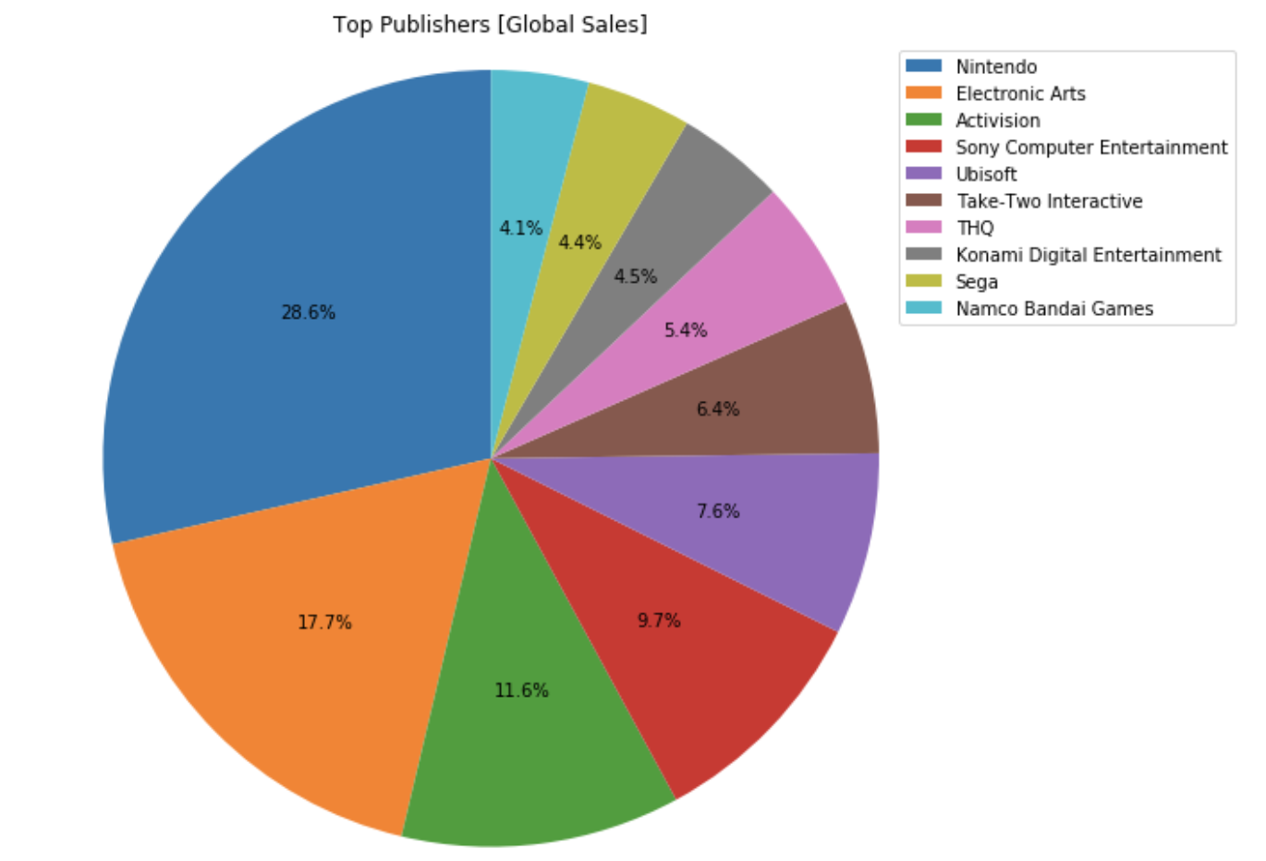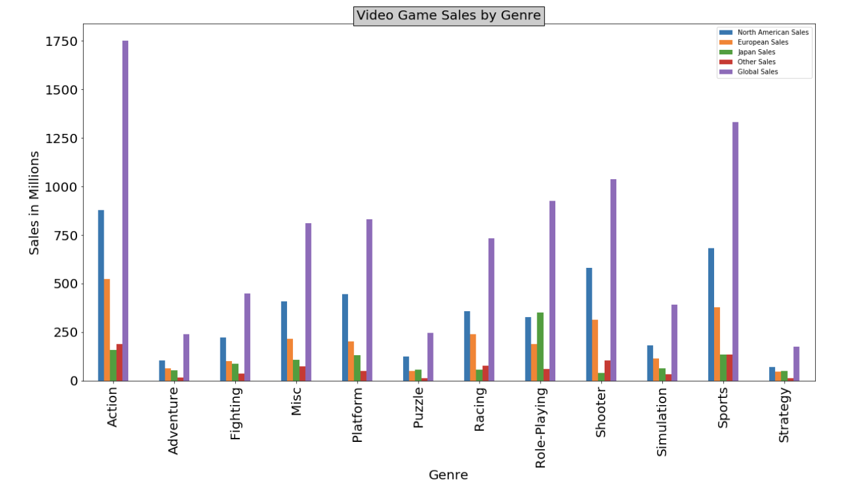

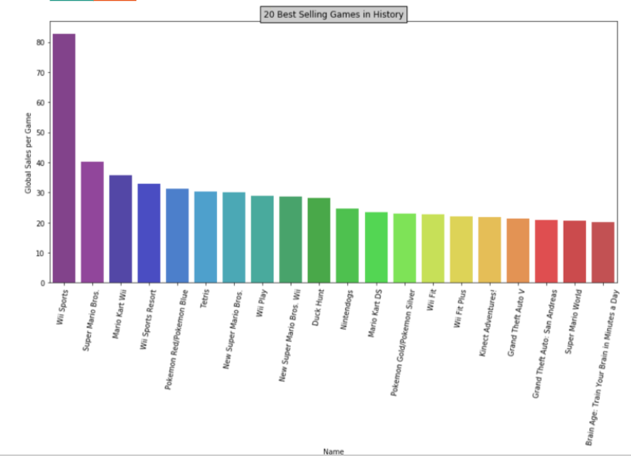

4. What are the top global video games and genres?

1. Why does Japan have the lowest shooter game sales and highest role- playing video games in comparison to the rest of the world?

During our evaluation of this bar chart we determined that the action category had the highest sales compared to the rest of the categories. Also while comparing this chart we found out that Japan had the highest sales compared to all other regions in the role-playing category. We determined that this is due to the increased popularity by the Japanese people in cosplay which concludes that role-playing games are more of a popular attraction. During further evaluation of the chart we concluded that North America and Europe have a similar trend in sales. Though Europe has fewer sales than North America they are both acquiring steady sales compared to each other in every category. We also concluded that the shooter category in Japan was very unpopular due to it being predominantly western developed.

